Air Power - Vector A
Penned by: M. Carter Brown

The Vector A, was the first version of the Vector to appear. They were released but do to a malfunction, all were recalled and transformed into Vector B's.

You can easily recognize the difference between the Vector A and the B version by the direct feed port. The Vector A's direct feed is about 1 inch forward of the sight rail, where-as the Vector B is directly underneath it.

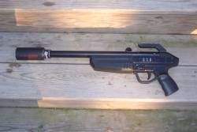
Air Power Vector A

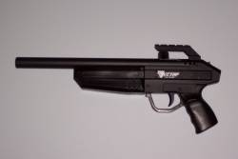
Air Power Vector B

Actually, nearly 2/3 of all the Vectors produced were originally Model A's.
Gino at N.P.S. (National Paintball Supply) bought 1000 Vectors and took delivery of Model A's. When Air Power came up with a better design (Model B), Gino sent the Model A's that he owned back to Air Power for upgrade to the B.

So, aside from the few that were bought by people before the recall, nearly all the Model A's were revamped before they were sold to the public.

Air Power put out the call to all owners of Model A's and offered them they upgrade for free. There were very few people (apparently) that did not take them up on the offer. At the time of this writing there are 4 remaining Vector A's (Verified and Accounted). Their respective owners are Drum, Have Blue, Painthappy (Myself), and one is located at the EMR Paintball Museum.

I purchased my Vector A from Ron P., hence the initials engraved into the gun. This gun was a gift to Ron by Gino. I was told that he was the original owner, and was given to him as a "prototype".

“Gino, was involved with the development and gave me the opportunity to be one of the testers. That’s how I came to own the one.”
- Ron

Knowing that most people hype up the guns they own… I didn't put too much stock into the notion. I purchased the gun on the basis that it was an "A" version of the Air Power Vector, and nothing more.

Upon receiving the Vector A, I promptly took it apart.

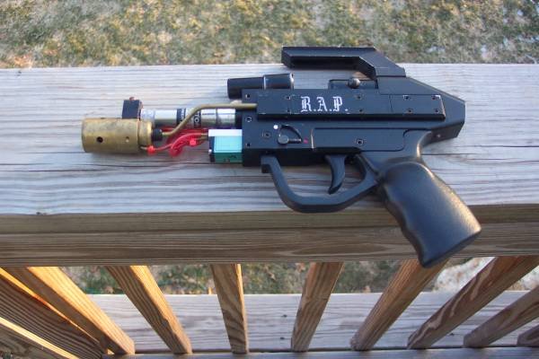

Please note that the above Vector is also a "Lefty" Vector. The Fire / Safety switch is on the left-hand side.

Serial #

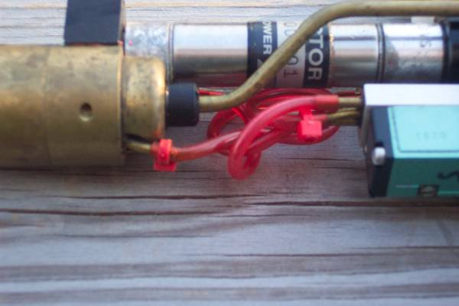

Aside from the view-blocking brass tube, it is indeed serial # 000001. Barring the existence of any prototypes, this is the first Vector to run off the assembly line. This is an extremely unusual find in many ways.

- Vector A
- Lefty Vector
- Serial # 000001

But mainly because it is the first one ever produced. These are nearly impossible to come by, only because the first of anything is usually held and kept by the respective companies owners, and not given away or sold. Therefore making this particular gun a valuable addition to any collection.

